**Analysis of the Cellphone Dataset**

Many people find it annoying when a cell phone goes off at the exact climax of a film. In Britain, there are four types of advertisements were sponsored by the Orange Cell Phone company to persuading patrons turn off their cellphone.

First, we test the hypothesis that the probability of a call is same for all ads. A regression analysis is NOT appropriate because ads variable is categorical. Instead, we conducted ANOVA. We found strong evidence that the probability of a cell phone interruption varied among ads (p<2.2e-16).

From plot 1, we can see that the probability of interruption for each ads is different. The DV ad has the lowest probability of a call, but there is no evidence that the DV is more effective because the confidence interval of DV overlap with the confidence interval of CJ, SS.

The odds of a call when no ad was played are 11.3 times larger than the odds of a call when the heavy breathing (DV ad) was played, the effect could range from 3.75 to 34.50. The confidence interval of odds ratio contain 0, so we can say the effect of DV ad on persuading patrons turn off their cellphone is statistically significant.

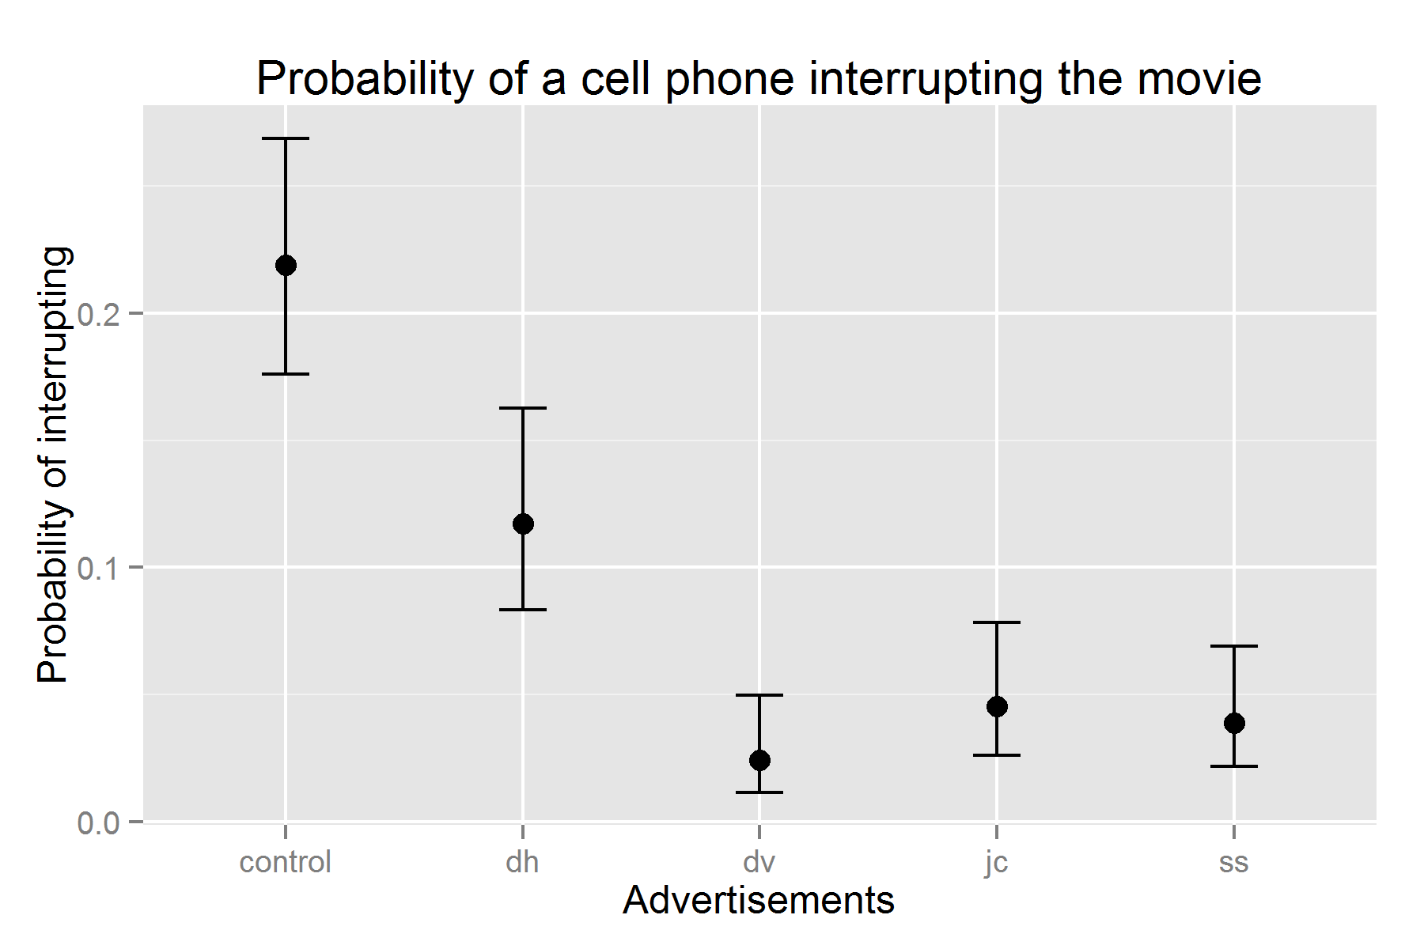

*Plot 1: the probability of a cell phone interrupting the movie for each ad with 95% CI*